Assistant
Shared API Key in useSlower responses due to throttling
Create a diagram that shows the architecture of a serverless application that manages a user directory. The application's frontend provides a search page that supports an auto-complete or auto-suggest feature when a user name is entered in a search field. Show both the frontend and backend components that support this architecture using best practices.
AI Assistant
I'll create a serverless architecture diagram for a user directory application with auto-complete functionality.

I'll create a serverless architecture diagram for a user directory application with auto-complete functionality. Let me first get the AWS icons available then design, a clean layout showing the frontend (user interaction, hosting) and backend (API, compute, storage, search) components.I'll create a serverless auto-suggest architecture with CloudFront for the frontend, API Gateway + Lambda for the API layer, and DynamoDB for the user directory storage. I'll use ElastiCache or DynamoDB Streams for optimizing the search/autocomplete feature, and organize it in clear tiers with proper spacing.I've created a serverless user directory architecture with auto-complete search capabilities.

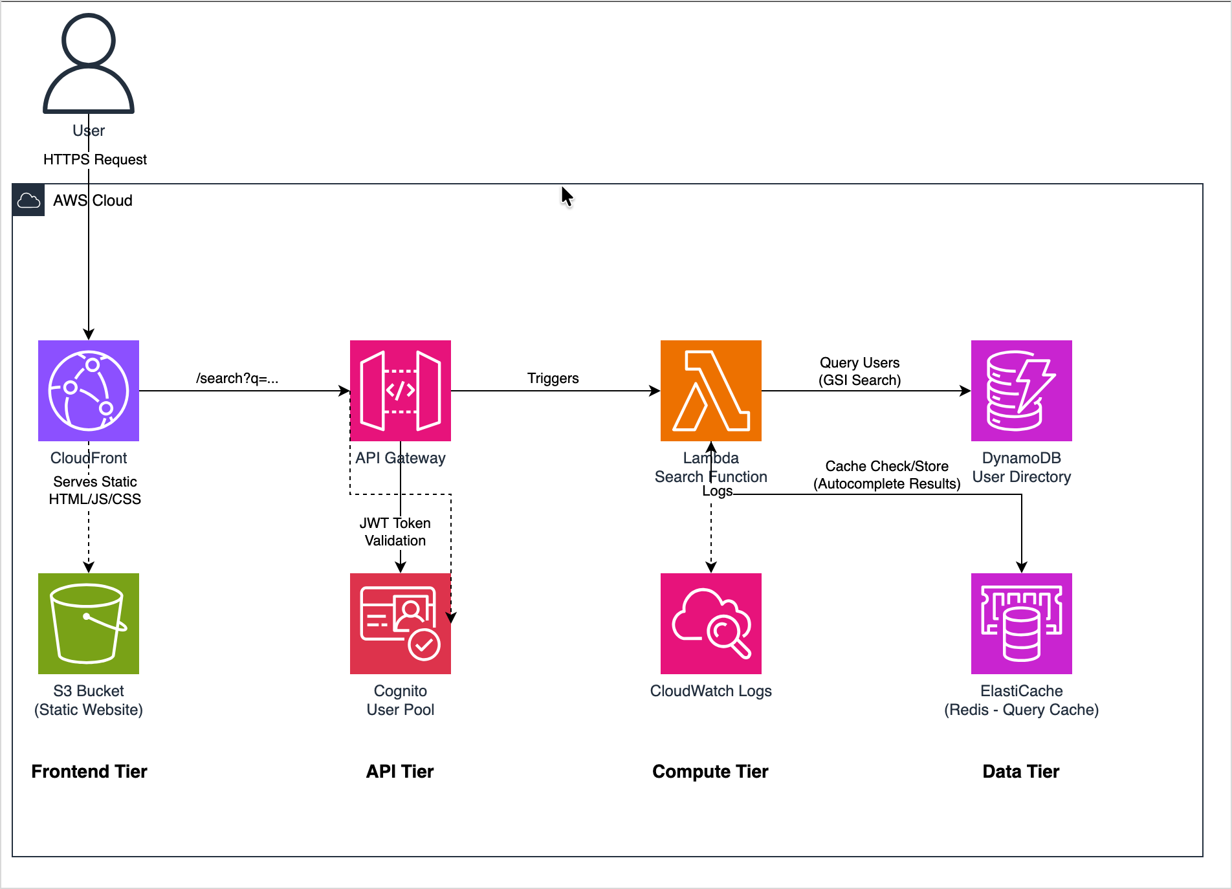

Link: https://drawio.corp.amazon.com/?embed=1&proto=json&spin=1&libraries=1

Here's what the diagram shows:

**Architecture Overview:** This is a modern, fully serverless application built on AWS that provides real-time user search with auto-complete/auto-suggest functionality.

**Key Components:

** *Frontend Tier:*
- **CloudFront** - CDN for global content3** - Hosts the static website delivery
- **S (HTML/JavaScript/CSS)

*API & Security Tier:*
- **API Gateway** - RESTful API endpoint for search queries –
**Cognito User Pool** - Authentication and JWT token validation

*Compute Tier:*
- **Lambda Function** - Serverless search logic that processes queries
- **CloudWatch Logs** - Monitoring and debugging

*Data Tier:*
- **DynamoDB** - Primary user directory database with GSI (Global Secondary Index) for efficient prefix searches
- **ElastiCache (Redis)** - Caching layer for autocomplete results to minimize latency

**Flow:**
1. User types in search field → triggers HTTPS request to CloudFront
2. API Gateway receives search query (e.g., `/search?q=joh`) and validates JWT token via Cognito
3. Lambda function checks Redis cache first for common queries
4. If cache miss, Lambda queries DynamoDB using GSI for username prefix matching
5. Results are cached in Redis and returned to user for instant autocomplete suggestions

This architecture follows best practices: serverless scalability, caching for performance, CDN for low latency, and proper authentication.
✓Loaded icon library19 chars
✓Generated diagram11068 chars
Save the conversation in a file that I can download
AI Assistant
I cannot directly create downloadable files, but I can help this you save conversation! Here are your options: **Option 1: Use the Draw.
I cannot directly create downloadable files, but I can help this you save conversation! Here are your options: **Option 1: Use the Draw.io Export Feature** 1. Click the **File** menu in the draw.io editor (left panel) 2. Select **Export as** → Choose your format: - **.drawio** - Editable diagram file - **.png** - Image format - **.svg** - Scalable vector format - **.pdf** - Document format **Option 2: Save the Conversation Text** You can copy this conversation by: 1. Selecting all the chat text in the right panel 2. Copy (Ctrl+C / Cmd+C) 3. Paste into a text editor and save **Option 3: Browser Screenshot** - Use your browser's built-in screenshot tool or a screen capture tool to save both the diagram and conversation together **Option 4: Print to PDF** - Use your browser's Print function (Ctrl+P / Cmd+P) - Select "Save as PDF" as the destination captures the - This entire page including both panels Would you like me to help you with any modifications to the diagram before you save it?
Attach

